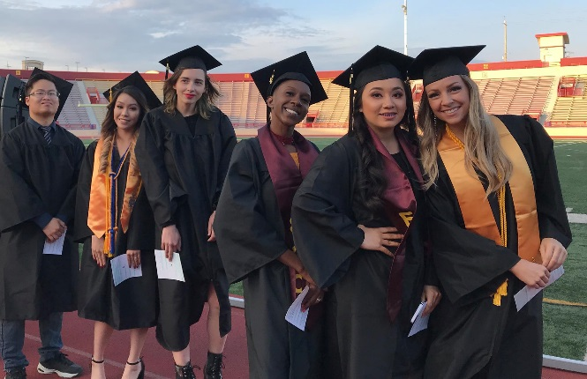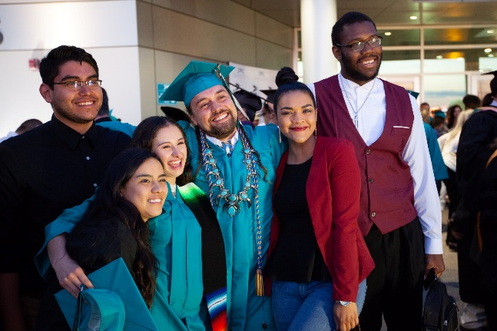
Why Give to Los Rios Scholarships?
The impact of a scholarship on a Los Rios student’s life is transformational. Scholarships allow students to take more units, work fewer hours, focus on school, and complete their goals in less time. They also ensure groceries on the table and more security. It is an investment in their plans and their futures.
The majority of our students are low-income and eligible for less financial aid than students attending four-year institutions. Due to the high cost of living in the Sacramento region, most students work 20 to 40 hours per week just to make ends meet.
Although community colleges provide the best value in higher education, the cost of books, supplies, and transportation are still substantial. Estimated books, fees and tuition are $2,500 per year for a full time student, and the cost of attendance for a low-income independent student is $19,821. Even for students who received all the financial aid available to them, they still have $6,674 in unmet need. This means most student must work more than 20 hours a week in order to pay for their education, and yet still cannot fully afford the associated costs. Scholarships bring higher education into the reach of students for whom an education might not otherwise be attainable.
Thanks to our supporters, the Los Rios Foundation provided $585,275 in scholarships to 957 students this year, including Josette who says: "Working five nights a week and going to school full time is a struggle. This semester I am taking Anatomy and Physiology along with Microbiology and another class. I'll be applying to nursing school this fall and these classes are very important to my success. This scholarship has allowed me to take a short break from work and be able to study and succeed in all my classes. I am so thankful for the opportunity."
A named scholarship can be established for as little as $500 a year. An endowed scholarship (exists in perpetuity) can be established for $10,000.
To establish a scholarship, complete and sign the attached form, and return to Kristin Emmett, Los Rios Colleges Foundation 1919 Spanos Court, Sacramento, CA 95825 or emmettk@losrios.edu. For questions, please call us at 916-568-3075.

Scholarship Agreement
Donor Information:
Name(s): __________________________________________________________________________________________
Address: ____________________________________________________________________________________________
Telephone: (_____) __________________________Email:_________________________________________________
Scholarship Information:
□ Endowed*: $__________________ Amount Endowed Initially ($10,000 Minimum)**
□ I plan to make additional gift to this in the future.**
□ Named (Three Years Minimum, $500/year): $____________ Amount Designated Initially**
□ I plan to make additional gift to this in the future.**
Scholarship Name: _______________________________________________________________________________
Scholarship Amount: ___________ ($500 minimum) # to Be Awarded Annually: ___________
Scholarship Criteria (Select Any That Apply):
□ I prefer to have the Scholarship Committee establish the criteria for the award.
□ Financial Need | □ GPA: __________ | □ Units Completed________  (6 units minimum)
□ Displaced Homemaker □ First Generation College Student | □ Displaced Worker | □ First Generation College Student
□ Former Foster Youth | □ Re-emerging/Formerly Incarcerated | □ Re-entry (Returning to college at least 7 years after high school)
□ Single Parent | □ Student Athlete | □ Veteran or Dependent of Veteran
□ Volunteerism | □ Working/Currently Employed | □ Other:_______________________  ________________________________
Students Attending: □ Any Los Rios College □ American River College □ Cosumnes River College □ Folsom Lake College □ Sacramento City College

Qualifying Major(s): _____________________________________________________________
(See last page for a listing of degrees and certificates)
Current Enrollment Status: Part-time Full-time (12 or more units)
Next Fall Enrollment: Transferring to a 4-year Continuing at Los Rios Graduating
Supplemental Material (i.e. Essay Question, Portfolio)

Biography of Donor (to be included on our website as well as to scholarship recipients)

______________________________________________________________ ______________________________
Donor Signature Date Established
* Additional gifts to endowment accounts will be added to the principal unless otherwise specified to be current use. Endowed accounts will be allowed to grow for at least one year before the first award is made. During that time, the donor may fund the scholarship award with a separate gift. The principal Amount available to spend is calculated each year in the Fall, and a report will be sent to donor.
** Scholarships that are funded via credit card are charged a 5% processing fee by our vendor. In order to be able to award the scholarship in full, please include an extra 5% when making your gift via credit card.
Please note: Laws governing charitable deductions dictate that donor cannot choose the recipient of the scholarship. Further, the California Ed Code requires that every community college shall provide its services, classes, and programs without regard to any protected category, so scholarship selection criteria cannot discriminate on the basis of race, color, ancestry, national origin, sex, age, religion, disability, or sexual orientation.

Many donors are interested in creating a scholarship for a specific field of study. The Los Rios colleges offer AA, AS and Certificates for the following programs:
Accounting | History
Administration of Justice | Horticulture
Allied Health | Human Services, including Gerontology
American Studies | Humanities
Anthropology | Interdisciplinary Studies, including Women’s Studies
Architecture | Journalism
Art | Kinesiology & Athletics including Dance, Fitness, Physical Education
Art History | Liberal Studies for Elementary Education
Astronomy | Library
Biology | Management
Business | Marketing
Business Technology | Mathematics, Statistics
Chemistry | Music
Communication Studies | Non-Profit Organization Management
Communications Media | Nursing
Computer Information Science | Nutrition & Foods
Construction Management Technology | Philosophy
Early Childhood Education | Photography
Economics | Physics, Physical Science
Emergency Medical Technology | Political Science
Energy | Project Management
Engineering | Psychology
English including Creative Writing, Education, Literature, Reading, Writing | Public Management
English as a Second Language | Real Estate
Environmental Technology | Sign Language Studies
Family and Consumer Science | Sociology
Fire Technology | Spanish
French | Student Government
General Education Transfer | Theatre Arts
Geography | Viticulture
Geology | Waste Water Management
Graphic Communication | Water Management
Health Education
For a full list, you can view our catalogs here: www.losrios.edu/lrc/lrc_catalogs.php

